CBSL 2020–2021
Toolkit to Support
Capacity Building Initiatives for Strategic Learning Initiatives

Contents
Context 1
How do I use this document? 1
CBSL Theory of Change Overview 2
CBSL Theory of Change 3
Theory of Change Template 4
Virtual Platforms for Cohort Communication 5
Virtual Meeting Facilitation Guide 6
Virtual Meeting Checklist 7
Before the Meeting 7
During the Meeting 7
Human-Centered Design Activity Guides 8
Activity #1: What’s On Your Radar? 9
Activity #2: Rose, Thorn, Bud 10
Activity #3: Problem Tree Analysis 11
Meeting Design Template 12
Virtual Meeting Agenda 13
Check-in Call Notes Template 15
Grantee Notes and Findings Synthesis Tool 17

Capacity Building for Strategic Learning Initiatives: Toolkit to Support Capacity Building for Strategic Learning Initiatives

Context
From May 2020 to September 2021, Mathematica and Catalyst:Ed partnered with the Bill & Melinda Gates Foundation and a set of nine K–12 education grantees for the Capacity Building for Strategic Learning (CBSL) pilot initiative. The partnership defined equity-centered strategic learning as the set of efforts that enables organizations to set goals that contribute to increased educational equity for Black and Latino students and students experiencing poverty; establish hypotheses on how to reach their goals; build strong organizational culture, practices and systems that support implementing and testing those hypotheses; and use information to improve their model on an ongoing basis. Critically, the partnership believes that strong equity-centered strategic learning is demonstrated when equity is considered in not only the organization’s goal but also in its learning and decision-making approach. The initiative’s goal was to strengthen grantee capacity for equity-centered strategic learning by helping grantees scope projects in their area of need, matching grantees with providers that could help build organizational capacity, delivering cohort learning activities, and offering thought partnership.

In its role as an intermediary, Mathematica created tools and resources that may be useful to funders and intermediaries looking to design a similar strategic learning initiative. The materials in this toolkit were created to facilitate strategic learning and can serve as a useful starting point, and the materials are adaptable to meet the differing needs and goals of initiative facilitators. A second toolkit containing resources on launching a virtual learning cohort for a strategic learning initiative can be found here.

How do I use this document?
As a facilitator of a strategic learning initiative, you can use this document to launch and sustain an intermediary-led cohort of strategic learning grantees. The toolkit includes guides on designing and facilitating meetings and templates for theories of change, meeting design, data collection, and data synthesis. All the resources in the toolkit are free to use and adaptable to meet the needs of users.

CBSL Theory of Change Overview
The Capacity Building for Strategic Learning pilot initiative created a theory of change to outline how building capacity for strategic learning through an intermediary-led learning cohort model will achieve impact and help participating organizations better work toward their goals through activities, outputs, outcomes, and impact.
The initiative’s theory of change, on the next page, demonstrates why strategic learning “works” and can be an effective use of resources.
- The problem statement at the top defines where the status quo model fails to serve all grantees in their learning efforts.
- The statement below describes the vision the funder and intermediary had for the initiative.
- The light blue columns outline the activities, outputs, outcomes, and impact that made up the Capacity Building for Strategic Learning initiative.
- The hypotheses at the bottom of the table were created by the funder and intermediary in the beginning of the initiative to serve as the guiding framework for data collection.
Page 4 includes a theory of change template, which you can adapt for your own initiative or strategic learning project.

CBSL Theory of Change
PROBLEM STATEMENT: There is not sufficient support for improving organizations’ capacity for equity-centered strategic learning that will help them better achieve their goals.
VISION: We believe that the Capacity Building for Strategic Learning (CBSL) initiative can (1) provide grantees with learning support and tools to build their capacity for equity-centered strategic learning and (2) generate evidence to investigate the argument that capacity building around equity-centered strategic learning matters and that funders can provide effective support in that space
Activities  If we invest in… | Outputs  We’ll see resulting… | Proximate Outcomes  Leading to short-term changes… | Outcomes  Leading to medium-term changes… | Impact  Ultimately impacting…
- Building grantee capacity in equity-centered strategic learning: Scope equity-centered strategic learning projects, match grantees with a provider, and provide advisory support during project implementation | - Provider-grantee relationships  - Grantee-intermediary thought partnership  - Time and space for grantee to reflect and improve equity-centered strategic learning  - Project-specific output | - Grantees apply new skills and/or knowledge to their work  - Grantees grow their desire for equity-centered strategic learning | - Grantees prioritize equity-centered strategic learning practices  - Grantees build an equity lens into organization’s goals, learning, and decision making  - Grantees can better advocate for strategic learning support | By improving service delivery and strengthening continuous learning and improvement, grantees are better able to equitably improve student outcomes through their work.
- Conducting learning activities: Form learning cohort and conduct learning activities focused on equity-centered strategic learning | - Cohort learning community  - Informal peer relationships  - Repository of learning resources on equity-centered strategic learning topics
- Learning about the capacity building (CBSL) model: Collect and analyze data on grantee experience with the CBSL initiative model | - Analysis of CBSL model  - Presentations and reports | - Funders understand how and why to support capacity building in strategic learning | - Funders prioritize CBSL initiatives
CBSL HYPOTHESES:
1a. There is a disconnect between what grantees would authentically like to learn about and what they are learning in order to report to funders.
1b. Funders can provide grantees the space and resources to sustainably build an equity lens further into the fabric of their organization’s goals, learning, and decision making.
2. Funders can effectively support capacity building by offering funding and cohort time, engaging an intermediary, and trusting that grantees know what they need better than the funder does.
3. If we create peer learning activities that are engaging and responsive to needs, then grantees will be better equipped to improve equity-centered strategic learning.

Theory of Change Template
PROBLEM STATEMENT:

VISION:

Activities  If we invest in… | Outputs  We’ll see resulting… | Proximate Outcomes  Leading to short-term changes… | Outcomes  Leading to medium-term changes… | Impact  Ultimately impacting…
HYPOTHESES:

Virtual Platforms for Cohort Communication
The pilot initiative considered several virtual chat and communication platforms to create a space where cohort members across organizations can connect outside of meetings organized by their funder and intermediary. Using a consistent virtual platform may help create a sense of community and serve as a space for cohort members to support one another on their strategic learning journey. Below are a few computer and mobile phone–friendly options that the pilot initiative discussed with the pilot grantees:
Platform | Description | Cost
Slack | Messaging app that allows teams to communicate with one another and share information and files. Messages are grouped into channels and direct messages to organize conversations. Slack also supports voice and video calls. | Free for small groups  $6.67 per user per month for small- and medium-sized businesses
Microsoft Teams | Messaging app for information and file sharing. Teams also supports voice and video calls. | Free for chat and collaboration  $5 per month per user for more administrative and security features
Trello | Web-based application that organizes and sorts tasks, notes, projects, and files into cards within different lists. | Free for standard features  Starts at $5 per user per month for more administrative and security features
Google Groups | Free service that provides discussion groups all in one folder for people sharing common interests. Users can choose to follow along via email and quickly find unread posts. | Free

Virtual Meeting Facilitation Guide
Before the meeting | Structure of the meeting
- Develop and provide clear information about meeting logistics for facilitators and participants.  - Share technology information and make sure participants know how to use any collaborative tools (if unsure, designate time before the meeting to show people how to use the technology).  - Send any pre-work that could prepare participants to engage during the meeting.  - This could include sending a few reflection or discussion questions in advance.  - Set up and test breakout rooms.  - Practice giving clear, explicit instructions throughout your meeting.  - Ensure all facilitators are comfortable using the tools. | - Keep groups small—choose your number of participants to align with your meeting goals.  - Thoughtfully group participants based on meeting goals (e.g., with an eye to diversity).  - Keep the sessions short (60–90 minutes) and incorporate regular short breaks.  - Use multiple facilitators.  - One facilitator serves as the lead; the other engages in the discussion and supports the lead facilitator.  - If you need to deviate from the established agenda, name that you are doing it and consider asking the group for permission.
Technology | Facilitation techniques
- Make sure facilitators know how to use the tools. Test run everything. Facilitators should know how the “host” function works and how to chat privately and to the full group.  - If you’re not sure that participants know how to use the relevant virtual tools, designate time before or at the beginning of your meeting to show people how to use the technology.  - Use the chat function as an active discussion area.  - Model using the chat: If you ask people to respond to a prompt, one or more facilitators should also respond. You can normalize using the chat by typing into the chat when it has not been prompted.  - Recognize that some people find it hard to follow the chat and live content at the same time, so consider how you are balancing requests to use the chat. | - Launch your meeting with a set of proposed norms, ground rules, or agreements to level-set on intent and expectations and maximize the time together.  - Consider doing a warm-up or ice breaker exercise, particularly if participants in your meeting do not know one another. In a larger group, you could use the chat to do this.  - Get comfortable with silence. Using the chat and allowing people to get their ideas written down there first can help with this.  - Give participants time to think and reflect before launching into discussion. If you pose a question for discussion, give participants one minute to think quietly and encourage them to jot down a few thoughts.

Virtual Meeting Checklist

Before the Meeting
- Develop and provide clear and easy-to-understand information about the meeting logistics.
- Share any important technology information in advance and make sure participants know how to use the tools. If not sure, designate time before the meeting to show people how to use the technology.
- Send pre-work to prepare participants to engage during the meeting.
- Keep the groups as small as possible (<10 participants) for active discussion, and use breakout rooms if needed.
- Set up and test breakout rooms in advance.
- Practice giving clear, explicit instructions throughout your meeting.
- Keep the sessions short (60-90 minutes, ideally).
- Assign multiple facilitators and make sure they are comfortable with and knowledgeable about how to use the tools.

During the Meeting
- Set expectations upfront.
- Consider doing a warm-up or ice breaker exercise.
- Incorporate regular breaks, particularly for any meeting 90 minutes or longer.
- Pay close attention to the time and your established agenda.
- Plan to engage all voices throughout the meeting.
- Use the chat function as an active discussion area.
- Be inclusive of people who called in via phone and are not on the video platform
- Plan time to be comfortable with silence. Give participants time to think and reflect before launching into discussion.

Human-Centered Design Activity Guides
We recommend incorporating and being attentive to your guiding values before, during, and after learning activities. We developed these promising practices based on the guiding values for our initiative, including choice, consistency, and flexibility. These promising practices can help you stay mindful of participants’ bandwidths and accommodate them accordingly.
Human-Centered Design (HCD) collaborative activities can be effective when used to support strategic learning initiatives. In the pilot Capacity Building for Strategic Learning initiative, HCD tools and activities were useful in the following ways:
- To solicit meaningful feedback from grantee participants
- To brainstorm learning activity meeting designs
- To facilitate collaboration among grantees
- For grantee use as a change management technique. Some grantees used the following tools to brainstorm in their internal strategic learning team on aspects of their strategic learning efforts.
This toolbox contains facilitation guides to three HCD-inspired activities. The recommended time is 15 minutes for the first two activities and 30 minutes for the last activity, but the timing can be flexibly adapted to fit your needs. Consider using the below tools to gather feedback, spark productive brainstorming, or guide grantee participants in their change management process. For more information on these or similar activities, check out resources from the Luma Institute.

Activity #1: What’s On Your Radar?
This is an exercise to draw out “top of mind” concerns, considerations and questions related to four different categories of your choosing. This is an especially helpful activity when trying to break the ice around a problem and to draw out ideas, causes for concerns, questions, or areas of opportunity.

Activity #2: Rose, Thorn, Bud
This is a generative exercise used to help participants reflect holistically on their experience in a targeted area. It can be helpful to warm up a team and give the facilitator information to gauge how a team is thinking about their work, identify potential areas for change, unpack the positive aspects of their work that they might build on, and explore opportunities for improvement.

Activity #3: Problem Tree Analysis
This next exercise allows a group to unpack and understand in detail the root causes and effects of a common problem statement

Activity #1: What’s On Your Radar?
- Develop four categories for brainstorming.
- For example, “use of technology” or “how we partner with schools”
- Set up a MURAL board or use a PDF.
- Ask participants to individually brainstorm ideas within each category, placing more important ideas closer to the center.
- Allow for small-group discussion, clustering of similar ideas, and prioritization.
- Wrap up with a discussion among the whole group.
- This activity is flexible: it can incorporate small-group discussion, and participants can discuss each quadrant separately or together.

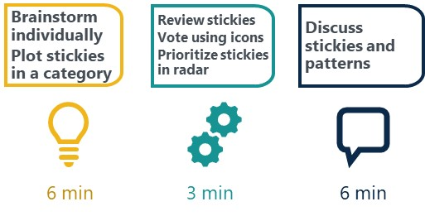

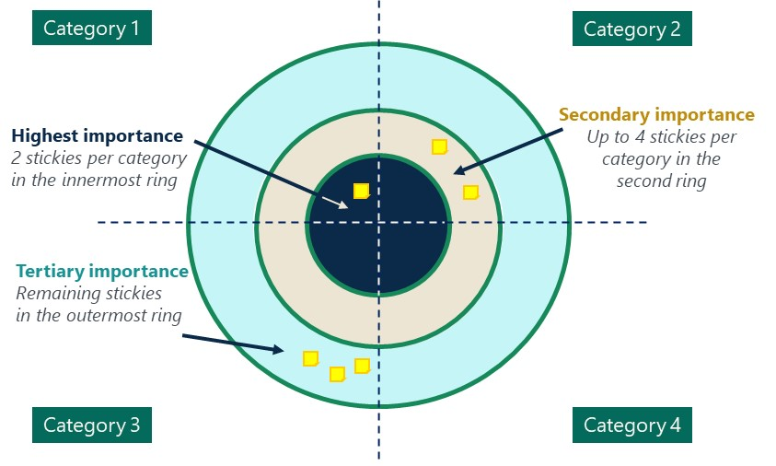

Activity #2: Rose, Thorn, Bud
- Develop a specific problem of practice or discussion prompt to ask your team.
- Set up a MURAL board with color-coded stickies for each participant or use a PDF.
- Ask participants the guiding prompt.
- Encourage them to fill out as many stickies as they can in 5 minutes.
- Allow for small-group sharing and clustering of similar ideas.
- Wrap up with a sharing among the whole group.
- Discuss and identify themes, if applicable.

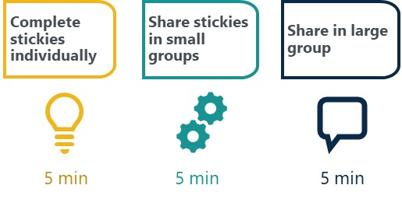

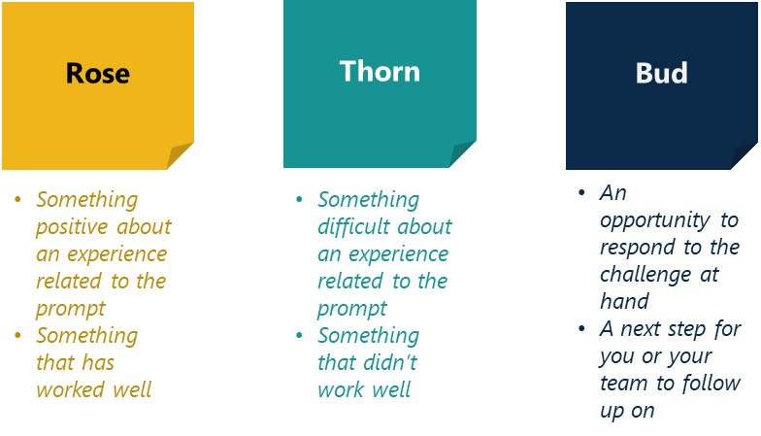

Activity #3: Problem Tree Analysis
- Use this exercise to help teams clarify and more deeply understand their motivations for change or shared root causes.
- Set up a MURAL board with the problem statement and structure or use a PDF.
- Individually brainstorm potential causes (one per stickie).
- Individually brainstorm potential effects (one per stickie).
- Review the stickies as a team, cluster similar ideas, and discuss.
- Vote for the most salient cause and effect by placing small stickies or symbols on your favorites.
- Wrap up with a discussion among the whole group.

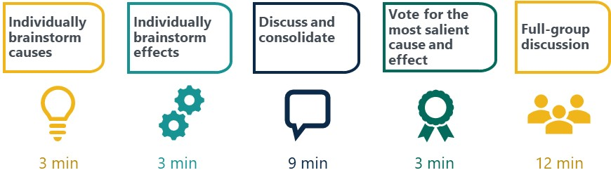

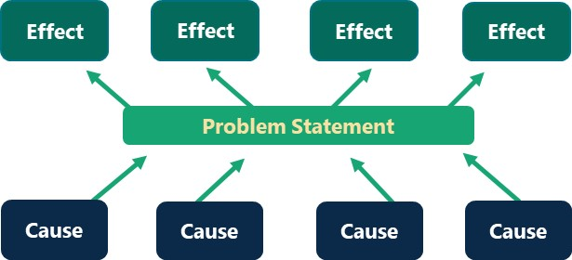

Meeting Design Template
This meeting design template was created to be adaptable for facilitating various learning activities. Creating this template was an iterative process as new needs arose. We identified key components that were important to have planned before a meeting, including times, agenda items, and content and logistics. However, that is not an exhaustive list, and facilitators can adapt this template as they see fit.

[Title of Learning Activity]

[date] from [time] to [time, time zone]
Location: [virtual (include link) or in person]
Presenting: [names of facilitators]
Participating: [names of participants]
Meeting objective: [outline the format and purpose of the meeting]

Key for meeting design | Notes for facilitator(s) | High-level agenda: Key times and activities
When creating a shared meeting design, it is important that all editors and viewers understand the typography. As you fill out this template, incorporate these elements:  - Bold – bold any names so that they stand out and can easily be seen. This will help everyone quickly identify who should be doing what and when.  - Italics – italicize all actions to differentiate them from talking points. For example, the command “start recording” should be italicized to ensure this action is completed. | - If participants are not asking questions during any of the Q&A sessions, feel free to identify and ask questions you think it would be good for the participants to hear.  - Provide links for any materials before the meeting, as well as in the chat during the meeting, if necessary.  - Embrace honesty and vulnerability when discussing complex challenges.  - Use participant feedback from previous meetings, if applicable, to improve your meeting.  - [insert other relevant notes]  Roles and responsibilities:  - [name] – moderator  - [name] – tech point person  - [name] – slides  - [name] – manage chat  - [name] – take attendance | 12:00 – 12:03 Join meeting (if virtual, invite participants to join early),  welcome everyone, go over meeting norms 12:03 – 12:04 Purpose  12:04 – 12:05 Agenda  12:05 – 12:45 Main content  12:45 – 1:00 Next steps

Virtual Meeting Agenda (this should align with the high-level agenda above)

Time (EST) | Agenda item | Facilitator | Content and logistics | Notes
11:50 | Join meeting | All facilitators and participants | Join video conferencing platform at least 5 to 10 minutes before the learning activity starts to set up and ensure all host and cohost functions are working well.  As participants join, start with verbal icebreaker – favorite thing about summer!  [name of slides person] displays welcome slide | Facilitator staff should log in to their video conferencing accounts before launching the webinar. Encourage participants to join a few minutes early to make sure their technology is working.  [insert and re-insert links into the chat as participants join]
12:00-12:02 | Join meeting | All facilitators | [Name of tech point person] starts recording  Welcome participants as they join the call.  [name] displays slide 2, “Meeting Norms”
12:02-12:03 | Welcome | [name of moderator] | [insert introductory welcome statement]  [insert speaking points for meeting norms]  [name] return to welcome slide  [insert speaking points for the introduction]
12:03-12:04 | Purpose | [name] | [name] displays slide 3, “Purpose”  [insert purpose statement and speaking points]  [name] flips to slide 4, “Speakers”  Introduce speakers.  [name] put link to bios of speakers in chat (if applicable)
12:04-12:05 | Agenda | [name] | [name] displays slide 5, “Agenda”  [insert agenda speaking points] | Remind participants that they can put questions in the chat.
12:05-12:45 | Main content | [name] | [name] displays next slide (If first speaker is not from the facilitator, they can share their screen instead).  [insert main speaking points]  [name] shares screen and flips through slides  [insert main speaking points]  *continue same format for each speaker as needed | If multiple speakers, discuss before who will be manage slides and screen sharing—the designated slides person or the current speaker.  To make sure speakers stay within their allotted time, remind speakers when they have two minutes left.
12:45-1:00 | Next steps | [name] | [name] shares screen and displays a wrap-up slide  [insert concluding remarks]  [name] stops sharing screen  Facilitate Q&A.  [insert prepared questions]  [name] shares screen and displays “Thank you!” slide  [insert final speaking points]  [name] provide link(s) to additional resources or a post-event evaluation form in chat  Ask participants to provide feedback by completing a survey.  Thank participants for joining.  Follow up with participants by sharing the slides and a link to the evaluation in an email after the activity. | If having a Q&A, determine ahead of time whether it will be moderated or unmoderated. If moderated, prepare questions or read questions from the chat. If unmoderated, prepare to keep track of timing. If too chaotic, use the “raise hand” function on the video conferencing platform.

Check-in Call Notes Template

[Participant name] Check-in Notes
This template outlines the information that we will collect at each [insert time interval – monthly, weekly, etc.] check-in call with participants. The goal is to track on an ongoing basis information that is helpful for (1) addressing your immediate needs and concerns related to your projects, (2) gathering information on your needs for designing future learning activities, and (3) capturing successes and challenges that can help understand the experiences of [participant name].

Reference Links and Notes
- Points of contact:
- Best days to meet:
- Goal: Use [insert time interval] check-in calls as a reflective exercise for all.
Because one of our goals is collaboration and transparency with participants, we are sharing this template with you in our first meeting to invite your feedback and ideas for running these check-ins.
Topic | Notes
Date | [Day, month, year of call]
General updates | [Add notes from call]
Project updates
- What has been going well? Are you seeing any meaningful changes to your organization from the project?
- What challenges have you faced, and how are you addressing them?
- What do you feel your organization needs for your successes to be sustainable?
- How do you see this work connecting to other work, projects, initiatives, or funders?
Equity
- How are you applying an equity lens in this work?
- Are there concrete steps you apply to keep equity central?
- What has gone well in centering equity in this work?
- What barriers have you encountered? How are you working to overcome them?
- What do you think is important for sustaining equity in [insert project]?
Feedback on the process
- What feedback would you offer to us to make this process better?
- What has worked well? What has been the most helpful support the project has offered?
- Is there anything else you needed or would have liked to see done differently?
Learning needs and activities
- Do you have any reactions or reflections on the most recent learning activity?
- How do you feel about the structure? What's working well? What would you like to see improved?
- What learning topics would be most valuable to your organization at this moment?
Questions for the organization
- Is there anything you would like us to convey to [insert partner/funder/organization]?
Action items
- Include future meeting topics.

Grantee Notes and Findings Synthesis Tool
This template offers a structure for how to synthesize notes and findings from check in calls with grantees. As with the other tools, please feel free to adapt to your needs. Access the spreadsheet tool here.

