Prior Research Table
This tool is part of Mathematica’s suite of measurement and evaluation (M&E) tools, which provides a road map for generating timely and actionable evidence about what works for whom, and in what context. The tools were designed to promote rapid innovation and scaling of promising solutions (such as programs, practices, or products). The Prior Research Table is used in Step 1 of the M&E process.
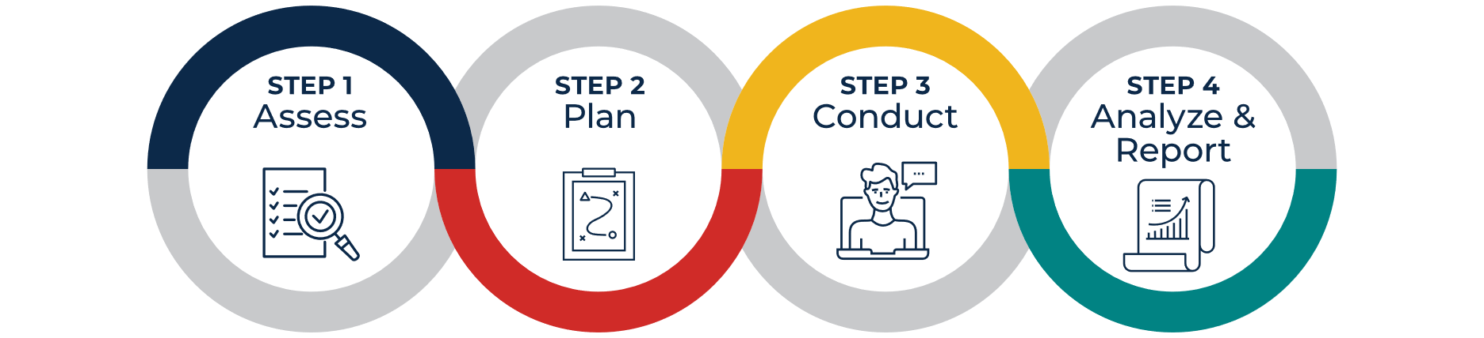
Learn more about the M&E process and other tools here: https://www.mathematica.org/features/advancing-educational-equity

Who should use the Prior Research Table?
This tool is designed for organizations implementing solutions with support from a research partner. The research partner could be staff within the organization with expertise in evaluation, or an external organization, technical assistance provider, or consultant.

What is the Prior Research Table?
When evaluating solutions, it is important to acknowledge and build on any research previously performed on that solution. The Prior Research Table is a template for organizing existing documentation and research. Building on previous findings can help organizations evaluating solutions make adjustments to implementation, articulate research questions, and set targets for desired change in outcomes.

Acknowledgments
Lindsay Fox, Megan Shoji, Ryan Ruggiero, Mikia Manley, Virginia Knechtel, and Kate Place developed this tool. Greg Chojnacki and Alex Resch reviewed the content and provided feedback. Grantee partners and Mathematica technical assistance liaisons also provided feedback on early versions of this tool. Sheena Flowers provided design and production support, and Jennifer Brown provided editorial support. This resource was prepared for the Bill & Melinda Gates Foundation. Views expressed here do not necessarily reflect positions or policies of the foundation.

Prior Research Table

The purpose of this tool is to help organizations document previous research on solutions to inform future evaluations. The tool starts with a question about the efforts made to understand the needs of the community the solution is intended to serve. It then provides instructions for populating the Prior Research Table.

Engagement with the community in focus
- How has your organization documented the extent to which your solution addresses the needs of the community (the group of people the solution is designed to or is intended to serve)? Please summarize this work at a high level.
[Click to add text]
- Has your organization documented the extent to which your solution addresses root causes of the problem you aim to address? How has your organization documented this information? If your solution targets outcome inequities, does your solution consider structural factors that contribute to those inequities?
[Click to add text]

Summary of prior research
Instructions: Complete Sections A to G for each study or analysis that either directly tested your solution (including impact and implementation studies) or informs your solution design. Include all studies of your solution, even those with negative or null findings, as well as qualitative studies that informed the design of your solution.
- In Section A, list the study citation.
- In Section B, indicate whether the study tested your solution. If no studies have tested your solution, include any studies that informed the development of your solution or that you might use to support a grant application to fund implementation and evaluation.
- In Sections C to F, indicate whether each item listed applies to the study, and provide additional details in Sections D and F.
- In Section E, indicate whether the study had statistically significant positive or negative outcome findings (select “Mixed” if both were present). If there were no statistically significant findings, select “Null,” even if there was positive or negative directionality.
- In Section G, briefly describe how the study supports your organization’s implementation of the solution.
Complete one table for each study. (Copy and insert more table templates as needed.)
Once the tool is completed, discuss with community in focus and research partner what questions remain unanswered and how additional research can build on the research previously performed on your solution.

Study 1
A. Study citation (authors, year, title, publication information) and URL link to the study¹:
[Click to add text]
B. Did this study test your solution? | ☐ Yes ☐ No | C. Type of study |  | ☐ Implementation² |  | ☐ Pre/post |  | ☐ Comparison group³
D. Outcomes assessed
☐ Teacher (if checked, specify)
[Click to add text]
☐ Student (if checked, specify)
[Click to add text]
E. Statistically significant findings | ☐ Positive |  | ☐ Negative |  | ☐ Mixed |  | ☐ Null
F. Did someone outside of your organization conduct the study?
☐ No ☐ Yes (please specify)
[Click to add text]
G. Describe how this study supports your solution:
[Click to add text]
¹ If a URL link is not available or the study has not been published, include a copy of the findings with this table.
² Implementation refers to how the solution was delivered and whether the solution was delivered as intended (that is, with fidelity to the model).
³ A comparison group study refers to a randomized controlled trial or a matched comparison design, where the outcomes of participants receiving the solution are compared to the outcomes of similar students not receiving the solution.

Study 2
A. Study citation (authors, year, title, publication information) and URL link to the study¹:
[Click to add text]
B. Did this study test your solution? | ☐ Yes ☐ No | C. Type of study |  | ☐ Implementation² |  | ☐ Pre/post |  | ☐ Comparison group³
D. Outcomes assessed
☐ Teacher (if checked, specify)
[Click to add text]
☐ Student (if checked, specify)
[Click to add text]
E. Statistically significant findings | ☐ Positive |  | ☐ Negative |  | ☐ Mixed |  | ☐ Null
F. Did someone outside of your organization conduct the study?
☐ No ☐ Yes (please specify)
[Click to add text]
G. Describe how this study supports your solution:
[Click to add text]
¹ If a URL link is not available or the study has not been published, include a copy of the findings with this table.
² Implementation refers to how the solution was delivered and whether the solution was delivered as intended (that is, with fidelity to the model).
³ A comparison group study refers to a randomized controlled trial or a matched comparison design, where the outcomes of participants receiving the solution are compared to the outcomes of similar students not receiving the solution.

Study 3
A. Study citation (authors, year, title, publication information) and URL link to the study¹:
[Click to add text]
B. Did this study test your solution? | ☐ Yes ☐ No | C. Type of study |  | ☐ Implementation² |  | ☐ Pre/post |  | ☐ Comparison group³
D. Outcomes assessed
☐ Teacher (if checked, specify)
[Click to add text]
☐ Student (if checked, specify)
[Click to add text]
E. Statistically significant findings | ☐ Positive |  | ☐ Negative |  | ☐ Mixed |  | ☐ Null
F. Did someone outside of your organization conduct the study?
☐ No ☐ Yes (please specify)
[Click to add text]
G. Describe how this study supports your solution:
[Click to add text]
¹ If a URL link is not available or the study has not been published, include a copy of the findings with this table.
² Implementation refers to how the solution was delivered and whether the solution was delivered as intended (that is, with fidelity to the model).
³ A comparison group study refers to a randomized controlled trial or a matched comparison design, where the outcomes of participants receiving the solution are compared to the outcomes of similar students not receiving the solution.

